Blue = 5

Orange = 10

Green = 15

Red = 20

Purple = 25

Brown = 30

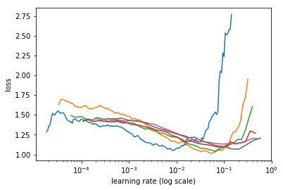

Loss VS Learning rate at different Batch size for resnet101, at 128 image size

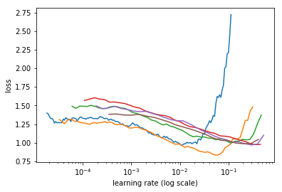

Loss VS Learning rate at different Batch size for resnet101, at 256 image size

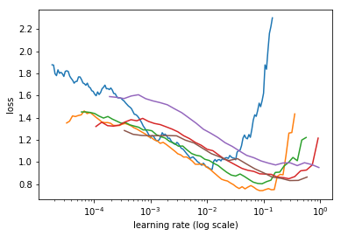

Loss VS Learning rate at different Batch size for resnet101, at 500 image size